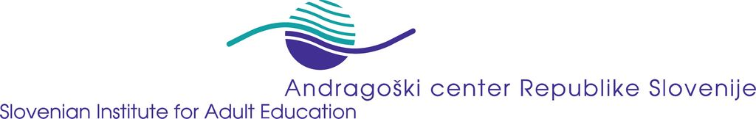

EU Project: Professionalisation of Literacy and Basic Education –
Basic Modules for Teacher Training: TRAIN

Reference-No: 229564-CP-1-2006-1-DE-GRUNDTVIG-G1

Dissemination activities

Project Partner: SIAE, Slovenia Period: 16.06.2006 – 12.10.2007

Date | Activity / Product  (e.g. event, media, publication) | Target group  (participants, user –  please specity quantity if possible) | Remarks
Continuously | - Communication among experts in the field on the competences  - Short description of the project is presented at the annual work plan of the SIAE | Adult Education experts and providing institutions, employed at the SIAE | The topic is actual and broadly discussed in Slovenian literacy field
Several occasions | Presentation of the propose, aims and topics of TRAIN project | Visitors and the guests of SIAE | Positive feedbacks
September 07 | - Involvement experts in the survey on literacy teacher competences.  - Website in the making | Project managers and trainers in the literacy field, university lecturers | TRAIN thought to be a very relevant project in the European context;

