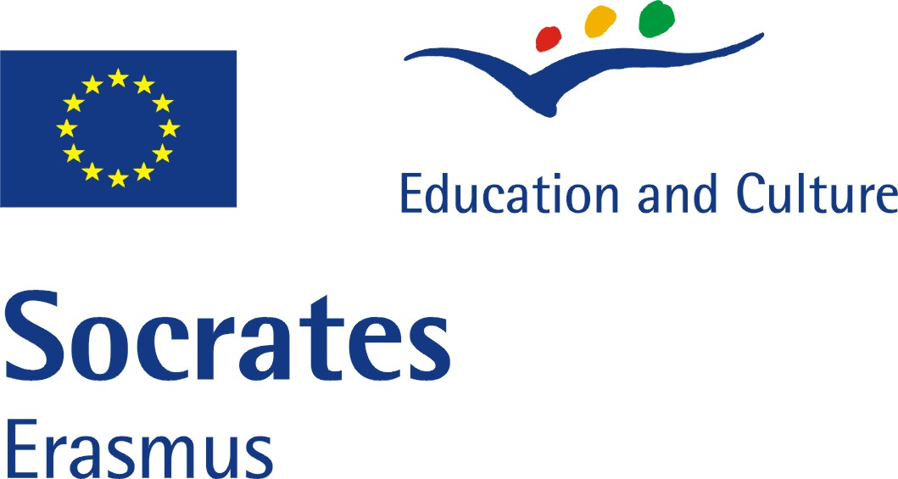
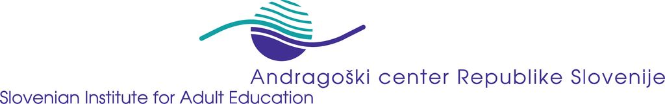

EU Project: Professionalisation of Literacy and Basic Education –
Basic Modules for Teacher Training: TRAIN

Reference-No: 229564-CP-1-2006-1-DE-GRUNDTVIG-G1

Monitoring Report 2

Reporting partner: Slovenian Institute for Adult Education

Reporting period: 16 June 2007 – 12 October 2007

Introduction:
As described in the project proposal it is planned to write regularly monitoring reports.

The reports should include information on:
- information about the progress
- establishment of local network
- development of concept for interviews with learners
- difficulties and weak points
- strategies of problem solving.

Remark: The frames are adaptable to the length of your answers.

Aspects for Monitoring Report

Progress of project
- activities undertaken during the reporting period
- Select the respondents among experts that might answer the questionnaire, establishing contacts
- translate the questionnaire into the Slovenian language
- Dispatch of the Profile of Competences to experts in the literacy field
- Exchange on the Questionnaire with the Experts by e-Mail.
- Data collection, evaluation of the experts’ responses and writing the reports both in Slovenian and English
- Numerous contacts with experts on the topic of professionalisation of literacy teacher training and exchange on the TRAIN project,
- Feedback on the evaluation of questionare to the respondents

- successful experiences and / or events
- The questionnaire has stimulated the communication about the very actual topic among experts – several experts have sent the comment that all of the competences mentioned at the questionnaire are very important. They find it difficult or almost impossible to select those that are less or even no important among. The evaluation of the experts’ responses gives an interesting starting point for further discussion both on the international and national level. Almost all of them became interested in the TRAIN project that might be important for the final event o the TRAIN – i.e international conference.

- difficulties and weak points
- The methodology of the questionnaire has it flaws, e.g. its bias towards the nomination “very important”. To be discussed in the next partner meeting,
- SIAE find difficult to collect fifteen questioners.
- feedback from others regarding the project
- Many positive feedbacks to the usefulness of the TRAIN project in general.
- Quite a lot of hints on the methodical flaws of the questionnaires.

Involvement of experts and establishment of local network within TRAIN
- With whom did you work together?
- With experts and experienced teachers in the field of adult literacy
- What have you done so far? What are your experiences?
- see above.
Dissemination
- What are your dissemination tools? (e.g. networks, magazines, newsletters…)
- Website www.acs.si are in the making considering the TRAIN project
- Newsletters NOVIČKE
- Workshops / Documentation
- Presentation of the SIAE to the visitors from the country and abroad
- National and local literacy networks (e.g. providers and teachers)
- Working papers, i.e. the country reports,
- Annual events e.g. Adult Learning Week and different sorts of other thematic bazaars e.g. Student Arena (organised by university’ students where SIAE is always invited to present the work)
- What have you done? - Overview of activities in general (in addition: please fill in the specific “dissemination form”)
- Please see separate dissemination report.

Development of modules
- First steps
- Collection of the materials (theoretical, good practice – i.e. models) and sources (e.g. lecturers, time)that is needed for the finalisation of the module,
- The rough contour of the module on roject Learning,
- Reflection of the all of 5 modules in the Slovenian context (e.g. what already exist/what is new; which of the modules are less/most presented in Slovenia (in fragments or as a unit itself; how they fit in the context of existing educational programmes for literacy teachers )

- Country specific aspects or interests

- The module about Social Marketing and ICT seemed to be less presented in Slovenian common educational programmes for literacy teachers and ate the same time we have less recourses and material in this field – we are at the very begging. In this way we hope to find new inspiration and construct new knowledge. At the same time we would like to reflect upon other modules esp. Project learning, because we think it might recover or bring at front some new aspects of the topic (problem) that we have been not averred of.

- Open questions
There is no open question at the moment.

Remarks, questions and / or recommendations
- Regarding the reporting period
-

- Regarding the further steps

- It might be useful to discuss the ways and means of support among partners during the implementation of 5 modules in particular country (if the need will occurred).

- Regarding the cooperation between the partnership

- Communication tends to be more intensive before and after partner meetings.

City / Date Ljubljana/ October 12, 2007

Report compiled by: Natalija Žalec, SIAE

