EU Project VisuaLearning

Group Discussions with Learners/Students

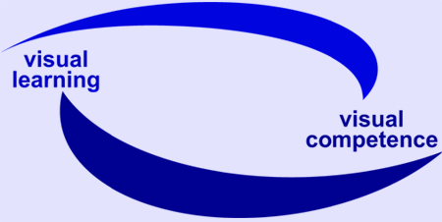







Bonn, October 2006

EU Project VisuaLearning


Outline for interviews with learners

Learner/student focus groups: guideline for interviewers

Introduction
As part of the EU Project “visuaLearning” we will be holding focus group meetings with students/learners.

The purpose of these sessions is to gather, from a sample of current students
in a variety of settings,

a) their experience of dealing with visual learning in everyday life;
b) their perception of how useful classroom learning is to this experience; and
c) their ideas for what would be helpful to their learning.

The sessions will be recorded and then transcribed. The data from these focus groups will be analysed with the method of qualitative content analysis by each partner. The findings will be summarized in reports, integrated in the course qualification concept and will become part of the handbook for trainers being produced by the project team in 2007.

This guide is for moderators and/or interviewers, to help make sure that we can be as consistent as possible in how we use these meetings to learn from students.

Remark: We would like to stress to follow these instructions very carefully. A common procedure within the partnership will ensure a comparative analysis of results.

What is a focus group?
A focus group is a group of individuals gathered to share experience on the topic that is the subject of research/evaluation.

The key characteristic that distinguishes focus groups from other data gathering methods is the insight and data produced by the interaction between participants.

A group usually consists of between 6-10 participants, who work with a interviewer/moderator through a set of pre-determined questions. We recommend to invite 4-6 participants. The interviewer/ moderator works with a tape and also with scribe to record in writing their responses and comments, catching verbatim phrases and comments where possible.

Focus group sessions usually last from one to two hours. We recommend that your sessions last for 90 minutes.

Who should participate?
Any learners of literacy or numeracy or foreign language in current classes. Furthermore it is highly appreciated and recommended to consider also elder learners (third age learners)! It's preferable if you don't already work with them yourself. We are concerned to ensure that we discover learner experience of visual learning/visual literacy.

Tasks of interviewer

Before the meeting:

- get in touch with the teacher/trainer and inform him/her about the project, the group discussion and ask for his/her support
- the trainer/teacher should inform and prepare the students – e.g. the students/learner should be sensitized for visual learning
- find and invite the participants for the group, fix a room, refreshments and name cards.

As a preparation of the group:

- ask the teacher to inform / motivate / sensitize the learners for visual learning
- ask the teacher to inform them in brief or in general about procedure/ group discussions (but no details about the method!)
- ask the teacher to talk and do some simple exercises about and perception of images and to talk about the fact that there are different learning types and learning styles
- ask the teacher to inform their learners that the participation is voluntary and that we will take care with the results (data will be anonymous!).

At the start of the meeting:

- welcome everyone by name and give yours;
- explain the purpose of the meeting; and that the group will be exploring some questions;
- clarify that you will be giving feedback at the end of the meeting for them to check and add anything.

Once things are under way, you will also need, as necessary, to

- encourage participation from everyone
- promote debate by asking questions
- challenge participants, to tease out different views
- probe for details
- move things forward when things drift or seem to be stuck
- steer the conversation back on course
- share note-taking work with your scribe

Allow 10 minutes or so for you and scribe to feed back to the group what you have gathered/learned from the discussion and check for any additions, questions or comments from the group.

Tasks of scribe
Eavesdrop while whole group working and take notes; when working with small group, use question and prompt questions to encourage participants to exchange responses with each other; do what you can to catch these responses, when possible including verbatim wording.

After the meeting:

- turn your notes into legible text;
- complete reflection sheet
- send notes and tapes to XXXXX by (date)

Timing

Remember you have 90 minutes, at least. As a rule of thumb, allow roughly 15 minutes for each of the first two questions, and then 20 minutes for the second two; with 10 mins for introduction and another 10 minutes The questions at the end to give back to the group something of what they have been saying: a kind of summing up.

The questions
It’s helpful to see each of the questions as a catalyst for discussion.
We have provided notes to suggest how you put them to the participants.
Explain that the first two questions are about visual learning situations in everyday life, as a way to help think about the second two, which are about how these situations get thought about and dealt with in class.

Introduction:
- Greeting
- Thanks and respect regarding their interest and engagement
- Information about anonymity
- Information about procedure (numbers of questions, duration, feedback at the end of the session)
- Introduction I – referring to images and signs, meaning of images and signs, perception, learning types and learning styles
- Introduction II: Tell about an example as a kind of demonstration/illustration/explanation:
  - Ask a question: How many window has the house – where you are living – on the front? Try to answer the question.
(Remark for the interviewer: Some of the participants will probably close their eyes to try to image the house. Some of them will probably answer the question.)
  - Ask a question: How could you succeed to answer the question? Do you know how it did work?
(Remark for the interviewer: The participants will probably answer that they did try to imagine the house first and that they then started to count the windows.)
  - Please explain: Normally no one will give the correct answer immediately or spontaneously. We have think about the house and to get a picture of it. Then or after that we can count. That means that knowledge can be saved as an “image”.
Normally that happens automatically, we do not think about it or not aware of it. But it happens in our daily permanently: we learn by (means of) images, sign and symbols – e.g. we get instructions by signs/signals – think about traffic, workplace….

The possibilities and advantages of learning by “visual communication” can be used and considered in learning situations as well. That is meant by “visual learning”. Within the project we try to get more information about that subject. For that reason we do the discussions because we are interested in your (the learners) experiences, observations and questions. Thank you again for your interest and participation.

Here are the questions:

- When you think about of the media, what are your habits of listening and watching?

Remark for the interviewer: Please let the learners tell about their experiences. In case there are problems to get into a discussion, please show some examples (see annex – there you will find some exemples) – or chose some from TV, newspaper, magazine, internet.

- In our daily life there are quite a lot of pictures, symbols or pictograms (– especially when we use new media - PC, internet, mobile phones, touch screens (e.g. ticket machines).

Remark for interviewer: Please show some three examples (see annex or choose own ones).

Please let the participants feel free to tell/discuss/ exchange their experiences. In case that the following aspects are not mentioned/considered after a while please ask the following questions:

Are you familiar with those “signs”? Do you like or appreciate them?

Are they helpful? Why? Why not? Can you think of something that might crop up for someone in this situation?
(the categories of the pictures, roughly, are intended to include:
working with others; family and friends; free time and interests – and you could add your own)

- Do you remember a situation where visual learning was helpful?

- Was it difficult to understand or to deal with visual symbols within the field of new media. What kind of competences does it need? How did you succeed?

- Do you know something about your learning style? What kind of materials or situations do you prefer? Why?

Use your discretion. Stress that the examples are of situations outside the classroom. Maybe give an example of your own to prompt discussion. Record examples they offer as you and your scribe think appropriate – maybe share on flipchart, maybe not. Encourage the idea that any story of the person getting help from someone else is absolutely fine.

- Is there anything you’re learning now in your class/group – or anything about the way that you’re learning – that you are finding particularly useful for you in dealing with learning or daily life situations?

Or: Is there anything that you’re learning in class that is particularly useful for you outside it?

Use follow-up prompts to elicit more, such as: “If so what/ how? If not, is there anything you would like to be doing more of?”

- What kind of support would you like to get? How do you help your teacher decide what to teach?

Give time for this question to sink in. Some students may see it as an inappropriate thing for them to do – or be unaware that they do it. Prompts and probes useful here. After discussion, you could offer as possible follow-ups: are there any topics you would like to study in your class that you have not yet? or: If you don’t help your teacher decide, is there any way you would like to in future?)

Remark for the interviewer: Please let the participants feel free to tell about their expectations/discuss / exchange their experiences. Then ask as a last question:

Would you like or appreciate a stronger/ more intensive integration of pictures/images/ - or visual elements in general into your learning group? Would you like to have more exchange and/or knowledge about the meaning of visual elements?

Final stage:
- Final remarks and conclusions
- Thanks for participation
- Feedback to the participants
- Information: If they are interested we will inform them about our results and findings.

Finally, some dos and don’ts of successful moderation:

Do | Avoid
value all contributions | participants addressing their answers to you
be familiar with the questions | making value judgements about contributions
listen carefully to what is said | spending too much time on one question at the expense of the others
promote interaction between participants (getting them to listen, too) | allowing one, or few members to hog the limelight
find a way to capture points made, even if these are not taken any further | taking sides in the debate
be clear about what will be done with the information from this meeting | interrupting participants as they express their views

Student focus group meeting: reflection sheet
– for scribe and to discuss/complete (informal notes are fine)
(please attach this as cover sheet to your notes of comments made for each of the four questions)

General information
Date, day and time of meeting:

Place meeting held (please give full address):

Moderator/interviewer:

Participants – personal data:
Please indicate if possible

Participant 1:
Age:
(w)women or (m)men): (w)………. (m)…….
Course:
Educational level:

Participant 2:
Age:
(w)women or (m)men): (w)………. (m)…….
Course:
Educational level:

How did it go? (any surprises? any problems? any moments of special illumination?)

Background information for Interviewers

Phases: Development of group discussions

Phases Sypmtoms/Phenomenons Reasons

Strangeness Careful wording; non-committal,
reinsurance

Orientation sound out; stimulating and Certainity; searching for provocative remarks joint action and solidarity

Adaption Consideration of former Need for agreement; interest
remarks in getting confirmation; group as „objecitve authority”

Confidence Taking a stand towards other group Aquainted with opinions;
Members; agreements, supplements; well-being in the community,
consensus fear of isolation

Conforming Homogeneous opinions; no “Infection”, idenfification;
differences; „monologues; concern about cohesion of
fall back on certain themes; group
partisanship against outsiders;
repulse of leadership; cover up
“faux pas”

Subside Decrease of tension; less Satisfaction with the
of discussion intensity; inattention; repeats conforming group; tiredness

Remark: In case the participants know each other, the first three phases may be dropped or skipped.

Examples of visual learning

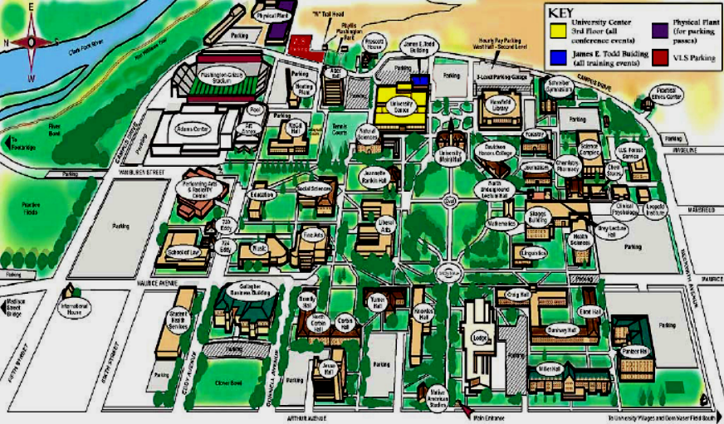

For more detailed information about the projekt please use the flyer or the information on the project web site.
Regarding the explanations about „focus groups“ we would like to thank our colleagues from the National Research and Development Centre for Adult Literacy and Numeracy (NRDC), London, to benefit from their findings.
Please explain if necessary what is meant by “pictograms”: pictograms are (graphic) symbols with an agreed and defined international meaning – e.g. “death’s-head (skull and crossbones) for poison.
Pollock, F., 1955: Gruppenexperiment. Frankfurt/Main. p. 456

