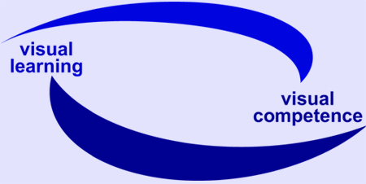

EU Project: visuaLearning

Reference-No: 225773-CP-1-2005-1-DE-GRUNDTVIG-G1

Monitoring Report 6

Reporting partner: DIE, Germany

Reporting period: 10. October 2007 – 15. December 2007

Introduction:

As described in the project proposal it is planned to write regularly monitoring reports.

The reports should include information on:
- information about the progress
- development of local network
- testing of qualification workshops
- development of qualification concept
- difficulties and weak points
- aspects regarding the final stage.

Remark: The frames are adaptable to the length of your answers.

Aspects for Monitoring Report

Progress of project
- activities undertaken during the reporting period
- 4th and final partner meeting in Dublin
- DIE-Forum „Exlusion – Inklusion, presentation of project
- Finalizing of concept
- Finalizing of analysis of group discussions. Report: Explorative Research: The relevance of visual learning for specific target groups
- Finalizing of project products: documents, reports, CD-ROM etc.
- Maintenance of website and gallery
- Newsletters
- Ongoing establishment of local network
- Ongoing dissemination (see overview of dissemination)
- Project management
- Support, guidance and counselling of partners
- successful experiences and / or events
- The activities were very successful
- difficulties and weak points

- feedback from others regarding the project
The feedback was very positive.

Involvement of experts and establishment of local network
- With whom did you work together?
We are still working in the network in three different cities:
- Community College in Bonn
- Community College in Eschweiler
- Berami in Frankfurt
- Landesverbände der Volkshochschulen
Bündnis für Alphabetisierung und Grundbildung

Furthermore we work together with nationwide association in the field of literacy and basic education to promote visual learning.
- Could you extend and/or strengthen the network? What are your experiences?
See above

Dissemination
- What are your dissemination tools? (e.g. networks, magazines, newsletters…)
DIE Magazine
DIE Newsletter
visuaLearning newsletter
DIE and visuaLearning website
DIE nationwide network regarding literacy and basic education
Network across Europe
Conferences, meetings and study visits on a national and European level

- What have you done? - Overview of activities in general (in addition: please fill in the specific “dissemination form”)
Newsletters
Presentations during conferences, meetings etc.

See dissemination form for further details

Further Development of qualification concept
- Further steps
During the partner meeting the partners decided on the common concept.
Finalizing of concept.
- Country specific aspects or interests
- Emphasize the importance of visual learning
- Strengthen the methodological knowlegde
- Strengthen the awareness concerning visual competences
- Open questions regarding implementation
We are looking for possibilities to promote the qualification concept.
have to find a common framework for the presentation of concept.

Preparation and testing of qualification workshops
- Recent steps
In Germany the workshops already took place in the previous period.
We used the reader but we deleted certain chapters, we overworked it and furthermore we did change a lot of pictures. We also integrated the findings from the group discussions we had.
- Country specific aspects or interests

- Open questions

- Further steps regarding implementation

Remarks, questions and / or recommendations
- Regarding the reporting period
The tasks all partners had to fulfil were challenging but all in all very interesting and successful.

- Regarding the final stage of the project
We are working on finalizing the products.
We will meet commitments.

- Regarding the cooperation between the partnership
We are all responsible to fulfil our tasks and commitments.

City / Date Bonn, 17th of December 2007

Report compiled by: Monika Tröster

