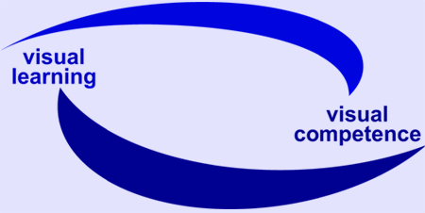

EU Project: visuaLearning

Reference-No: 225773-CP-1-2005-1-DE-GRUNDTVIG-G1

Monitoring Report 7

Reporting partner: DIE, Germany

Reporting period: 16. December 2007 – 31. January 2008

Introduction:
As described in the project proposal it is planned to write regularly monitoring reports.

The reports should include information on:
- information about the progress
- establishment of local network
- testing of qualification workshops
- development of qualification concept
- difficulties and weak points
- aspects regarding the final stage.

Remark: The frames are adaptable to the length of your answers.

Aspects for Monitoring Report

Progress of project
- activities undertaken during the reporting period
Finalizing of project products
Finalizing of Final Report

In addition: carrying out two workshops during a conference in Northrhine-Westfalia
- successful experiences and / or events
Positive feedback
Requests for carrying out further workshops in Germany
- difficulties and weak points
Workload and time pressure

- feedback from others regarding the project
Positive feedback

Involvement of experts and establishment of local network
- With whom did you work together?
We are still working in the network in three different cities:
- Community College in Bonn
- Community College in Eschweiler
- Berami in Frankfurt
- Landesverbände der Volkshochschulen
Bündnis für Alphabetisierung und Grundbildung

Furthermore we work together with nationwide association in the field of literacy and basic education to promote visual learning.

- What are your experiences?
See above

Dissemination
- What are your dissemination tools? (e.g. networks, magazines, newsletters…)
DIE Magazine
DIE Newsletter
visuaLearning newsletter
DIE and visuaLearning website
DIE nationwide network regarding literacy and basic education
Network across Europe
Conferences, meetings and study visits on a national and European level
- What have you done? - Overview of activities in general (in addition: please fill in the specific “dissemination form”)

Newsletters
Presentations during conferences, meetings etc.

See dissemination form for further details

Remarks, questions and / or recommendations
- Regarding the reporting period
Within the project we developed a lot of interesting materials for teachers and we are happy because the feedback is very positive.

- Regarding the final stage of the project and its sustainability
There are certain ideas and even requests to carry out workshops after the end of the project.

- Regarding the cooperation between the partnership
The engagement of the partners was different but all in all we succeeded and we are happy to present our findings and materials.
City / Date Bonn, 31. January 2008

Report compiled by: Monika Tröster/DIE

