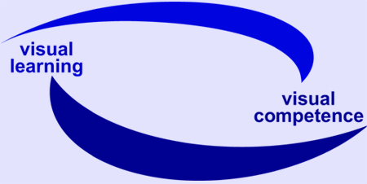

EU Project: visuaLearning

Reference-No: 225773-CP-1-2005-1-DE-GRUNDTVIG-G1

Monitoring Report 5

Reporting partner:

Reporting period: 1. May 2007 – 30. September 2007

Introduction:

As described in the project proposal it is planned to write regularly monitoring reports.

The reports should include information on:
- information about the progress
- development of local network
- group discussions with learners
- preparation and carrying out of qualification workshops
- development of qualification concept
- difficulties and weak points
- strategies of problem solving.

Remark: The frames are adaptable to the length of your answers.

Aspects for Monitoring Report

Progress of project
- activities undertaken during the reporting period
Organised three one-day Visual Learning workshops for adult literacy teachers
Also, ran one half-day visual learning workshop at NALA ‘Make the most of your brain’ event in Dublin as a sort of trial run for the one-day workshops

- successful experiences and / or events
yes, the feedback was generally very positive from the three workshops. A minority of people were unhappy with the contents, but from reading their criticism, it seemed that they did not read the information on the workshop before attending

- difficulties and weak points
none that I can remember

- feedback from others regarding the project
very positive regarding course contents and facilitator (Jane Smith)

Group discussions with learners
- Description of target group(s)
See Monitoring Report 1 December 06 to 30 April 07

- Results and findings

- Consequences for the workshops and the qualification concept

Involvement of experts and establishment of local network
- With whom did you work together?
Jane Smith, adult literacy tutor and trainer from Ireland who attended training in Bonn

- Could you extend and/or strengthen the network? What are your experiences?
I think if we’d more money, we could put on more one-day Visual Learning workshops and people would attend

Dissemination
- What are your dissemination tools? (e.g. networks, magazines, newsletters…)
Flyers (advertisement) sent to adult literacy centres, Senior Traveller Training Centres, Youthreach centres, National Learning Network centres, Prison Education centres. Passed on information at NALA events. Advertised events on NALA website

- What have you done? - Overview of activities in general (in addition: please fill in the specific “dissemination form”)

See above

Development of qualification concept
- First steps and experiences
Jane Smith and Fergus Dolan attended training in Bonn. We then developed one-day programme aimed specifically at adult literacy tutors

- Country specific aspects or interests
Practical exercises for adult literacy students

- Open questions

Preparation and testing of qualification workshop
- First steps and experiences
Developed workshop. Tested it at half day workshop as part of a NALA conference on 23 April 2007 - ‘Making the most of your brain’. – made a few minor changes as a result of the half-day workshop

- Country specific aspects or interests

Visual mind mapping was very popular with adult literacy tutors – they felt that it’s an ideal technique to use with adult literacy students

- Open questions

- Further steps
Adapted half-day workshop to full-day workshop with a nice balance of theory and practical exercises

- Consequences for the qualification concept?

Balance good

Remarks, questions and / or recommendations
- Regarding the reporting period
Workshops were great success. Originally we had two planned workshops, but bookings were so strong that we put on a third. Between 20 and 25 attended each

- Regarding the final stage of the project

Strong interest in the project

- Regarding the cooperation between the partnership

Very strong, cooperation great

City / Date Dublin, 23/11/07

Report compiled by: Fergus Dolan, NALA

