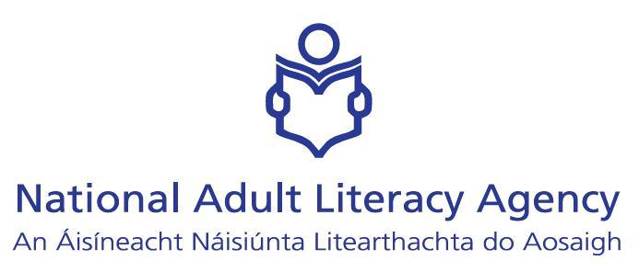

EU Project ‘Visual Learning’

Report on Visual Learning workshops for Teachers - Ireland

Summary - Evaluation – Feedback

- What did you change in comparison to the qualifications workshops in Bonn? Why?

I used the workshop delivered in Bonn for the first two sessions with adjustments to target the learner profile and standard of learning with which tutors in Ireland would be working i.e. learners working towards functional literacy. I did this because tutors attending professional development sessions in Ireland always look for something to take back to the learner and as such the workshop aims and objectives always involve practical sessions that can be adapted for use with learners.

The other change from the Bonn workshop was that the session on participant learning styles and the computer profiling of the same was excluded. This was not, in my opinion, a readily transferable session for several reasons. Primarily this session did not work for me in Bonn and I felt the participants did not welcome it in general. Awareness of our learning styles is, of course, essential for tutors but valuable workshop time was used to provide a personal profile of which I was already aware. To use this session in our workshop would have produced similar frustration in the participants in Ireland.

- Did you change your concept after the first national workshop?

No change in the workshop concept occurred. Some time management and technical issues were addressed to allow the workshop to become more effective.

- What are your impressions/results regarding the workshops?

Four workshops were delivered. The feedback from 3 of the 4 was extremely positive, with high levels of satisfaction recorded on the evaluation sheets. The 4th workshop (2nd in chronological order of delivery) recorded less satisfaction on the evaluation sheets. The reason for this revolved around some technology issues at the hotel, which delayed and slowed down the workshop, as required equipment was not present. Also, some of the tutors in this workshop were teaching media studies. These tutors had anticipated a stronger link within the workshop to ideas and materials for use in media studies. Obviously they felt their needs had not been met.

- Did you get any information from the teachers about their learners and their learning biographies?

There were opportunities in the workshop for teachers to discuss their learners and their learning biographies. This occurred informally in small groups or partner work and also in the feedback sessions of large group discussions.
Tutors were aware that learners did not have access to computers either at home or in learning centres and questioned their possibilities for using picture banks. The access to visual material would be limited for the target groups being dealt with.
The learning biographies suggest that the learners disregarded visual materials in the same way that they disregard written text. They use coping strategies i.e. asking someone for directions rather than using a map.
It was agreed by all the groups that tutors have a responsibility to bring more visual material into the learning environment and to work with it as is done with text based materials.

- What are your recommendations and results regarding the final concept of workshops?

As a result of the evaluation of the workshops I would suggest that tutors in Ireland felt that the visual learning workshop as delivered provided a basis for developing visual learning methodologies and concepts with their own students.
More experienced tutors agreed that the workshop had ‘jogged their memories’ about visual learning. They accepted that it has become even more important to have the theory and concepts of visual learning to the forefront of literacy practices. I feel that the final concept of the workshops worked for Irish tutors, reviewed the knowledge they already had and presented the possibility to develop more knowledge and expertise in the area.

- What kind of support do the teachers need to integrate visual learning into their teaching?

- In practical terms, specific computer and technology training for visual learning for tutors and students. This suggests learning centres should provide more computer equipment and access to computer rooms even when not part of a scheduled computer programme.
- Central image banks accessed through CD-ROM or via the Internet would be important.
- Colour printing for reproduction of images – images lose their impact when printed in black and white.
- Further workshops to allow tutors with a specific interest in the area to develop a depth of knowledge in the area of visual learning. These tutors could become mentors in their own centres and this would help new and inexperienced tutors to develop visual learning methodologies.
- A selection of recommended reading to be available on the subject of visual learning.
- More emphasis in initial tutor training programmes on visual learning.
- Some templates for brain storming, mind mapping and clustering to be available to tutors.

