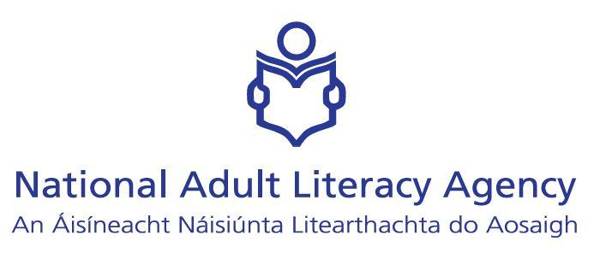

EU-Project: Visual Learning Workshop

National Adult Literacy Agency (NALA)
Evaluation Feedback Report
Dublin, 15 June 2007

Please answer the following questions:
1. What were your expectations of this workshop?
- tips on teaching spelling through visual lerning
- to understand how visual learning works
- new ideas, new ways of learning
- to find out what's meant by visual learning
- learn how to be more creative
- gain a clear understanding of visual learning
- ideas to make reading and writing more attractive
- to re-energise my teaching techniques
- to develop new strategies for working with students
- to learn about a new tool for literacy work
- understand visual learning and get practical ideas for work
_____________________________________________________________________

2 To what extent have these expectations been met?

- Useful
- happy that awareness is increased
- have learned a lot about visual learning
- 100%
- have now ideas and techniques
- very well
- very helpful
- perfectly
- some have been met
- fully
- Yes, above and beyond expectations

_____________________________________________________________________

3 Please award the following sessions a rating on a 1 to 10 scale where:
1 is the lowest rating and 10 is the highest rating.
Please also include a short comment if you wish.

Session A: Ice-breaker - Choosing a Picture

Rating

- 9
- 9
- 7
- 8
- 8.5
- 10
- 8
- 10
- 10
- 10

____________________________________________________________________

Session B: What is Visual Learning?

Rating

- 8
- 8
- 7
- 9
- 8.5
- 10
- 8
- 10
- 10
- 10

Session C: Power of Images

Rating

- 9
- 8
- 10
- 7
- 8
- 8
- 10
- 8
- 6
- 10
- 10
____________________________________________________________________

Session D: An overview of Mind-Mapping

Rating

- 58
- 8
- 10
- 8
- 9
- 8
- 10
- 7
- 7
- 10
- 10

_____________________________________________________________________

Session E: Creation of a Mind-map using images

Rating

- 8
- 9
- 10
- 10
- 8
- 7
- 10
- 10
- 8
- 9
- 10

Session F: Skills development from the Learning Map

Rating

- 7
- 10
- 7
- 8
- 9
- 9
- 9
- 8
- 9
- 10

_______________________________________________________________________

Session G: Visual Learning applied to spelling

Rating

- 8
- 7
- 10
- 7
- 9
- 8
- 10
- 9
- 9
- 9
- 10
__________________________________________________________________

4 Which session(s) did you find most useful?
- A & C
- D
- D & G
- D
- A, B & C
- G
- G
- E

5 Which session(s) did you find least useful?

- All useful
- None
- None
- All useful
- None
- D
- None
- C
- B
____________________________________________________________________

  - What would you change in the workshop?

- Louder facilitator
- definitions of different kinds of learning
- nothing
- nothing
- nothing
- nothing
- nothing
- no personal spelling list
- nothing

  - Please add any additional comments here.

- facilitators approach refreshing
- facilitator was excellent
- very good
- Thanks Jane Smith
- presenter excellent
- list of resources, websites, materials
- presentation brilliant
- Lots of ideas

What are your general impressions regarding the workshop?

This was a good workshop, well received by the tutor group. The tutors enjoyed all the sessions within the workshop.

- Session 1- Using pictures as an icebreaker.
The tutors thought this was a good exercise. They spoke of It as jogging their memories and saw it as useful for students.

- Session 2- The power of images.
The slide show of images and the discussion was a good exercise. The tutors were surprised at the variety of images students might be exposed to. In the category section they discussed the need for maps, symbols and images to be used more frequently with students.

- Session 3- Mind Mapping.
This was also a good session. Most tutors had used mind mapping themselves but had not considered using it with students. They saw that using visuals only in a mind map could allow visual learning for a group of basic students.

- Session 4- Teaching spelling with visual methodologies
All the tutors enjoyed this session and commented that it had a very practical application in the classroom.

The teachers experience concerning the visual competence.

Tutors felt that their own competence in the area was limited. Also that students would have little exposure to visual strategies and so would not be competent with them.

Tutor Evaluation of Visual material presented in the course.
They felt in general that they had expanded their own knowledge of visual methods and that the ideas given in the course could work for students.

