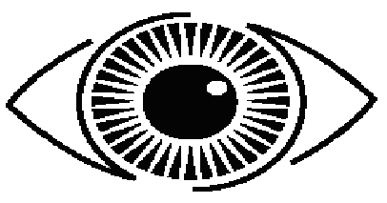
Learn to see. See to learn.
Learn to see. See to learn.

Visual literacy is the set of skills involving the understanding and interpreting of images. The concept of visual literacy is the ability to create and use images to communicate. The basic skills of visual literacy include the vocabulary necessary for the understanding and discussing of images and visual symbols.
Visual literacy is not limited to modern mass media and new technologies. Animal drawings in ancient caves, such as the one in Lascaux, France, can be seen as early forms of visual literacy.
Visual learning is a method of teaching and learning that uses pictures and images as a way of working with ideas and presenting information.
Visual learning helps learners make;
- abstract ideas visible and concrete,
- connects prior learning and new concepts,
- provides structure for thinking, writing, discussing, analyising, planning and reporting and
- focuses thoughts and ideas leading to understanding and interpretation.

Reading and writing with images.

