Methods:

Mnemotechniques: techniques which support the process of remembering in a quicker way. The most popular are described below:

“Memory hooks” - is a technique of better remembering and creating the association systems: a technique of fixing memory „hooks” which allow to remember numbers, quantities, relations, greater narrations, etc.
The examples of memory „hooks”:

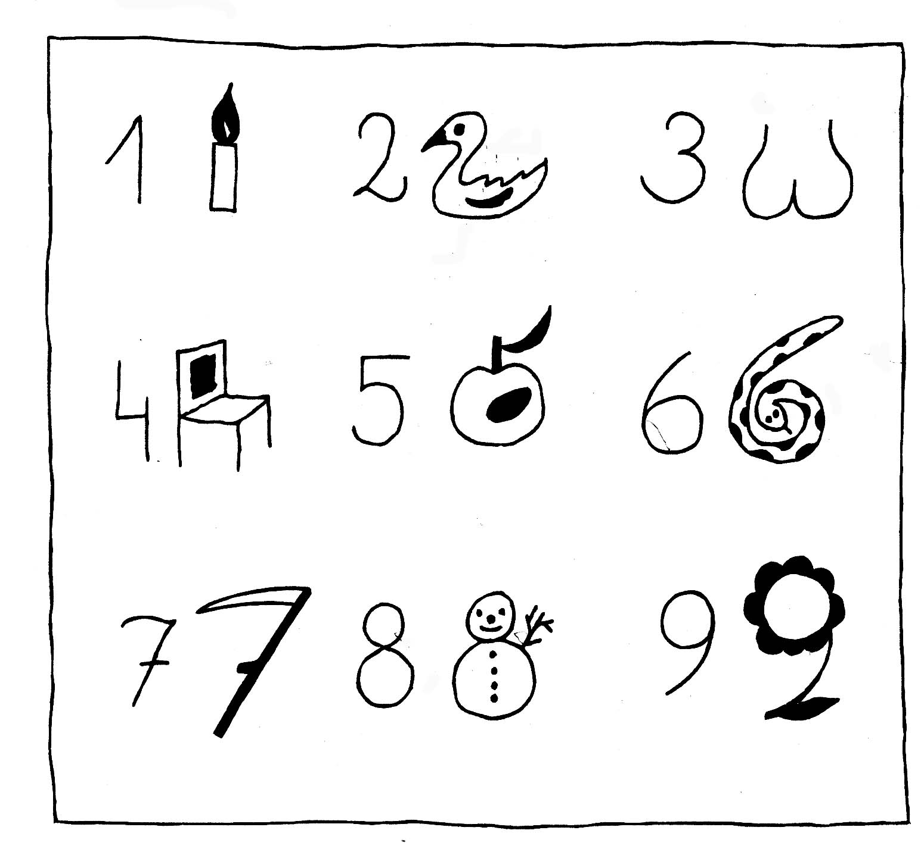
Another examples:
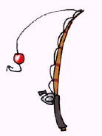1
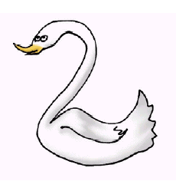2
3
 4
5
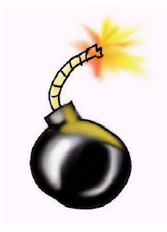6

Story telling – As a learning tool, storytelling can encourage students to explore their expressiveness. It helps to improve imagination. In order to remember some abstract vocabulary or terms, students create own story using the words that have to be remembered. Important remark: there is no stupid stories. Each is individual and what is important – as much it is abstract as less it takes to remember it. This method is especially useful when some words, events not connected each other have to be remembered.

Taraszkiewisz M., Jak się uczyć lepiej, (How to learn better?), Centrum Doskonalenia Nauczycieli, Warsaw 1996.
Haki pamięciowe (Memory hooks), Taraszkiewicz i Janusz Lasota TRENDY uczenie w XXI wieku Internetowy magazyn CODN nr 3/2005.

