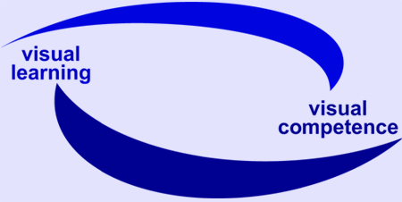
EU Project visuaLearning

Reference-No: 225773-CP-1-2005-1-DE-GRUNDTVIG-G1

Dissemination activities

Project Partner: DIE, Germany (Project Coordinator) Period: 1.12.2006 – 30.04.2007

Date | Activity / Product  (e.g. event, media, publication) | Target group  (participants, user –  please specity quantity if possible) | Remarks
07.12.2006 | EU Project TRAIN: Professionalization of Literacy and Basic Education – Basic Modules for Teacher Training  Open session and with experts from Slovenia and TRAIN kick off meeting  Presentation of visuaLearning  Ljubeljana | Researchers from the University of Ljubljana and SIAE (TRAIN partner), practitioners form the SIAE network  20 participants | Experts from Slovenia were very interested.
21.12.2006 | Project Newsletter No. 1 | Trainers, tutors, researchers, | www.die-bonn.de/visual
13.02.2007 | 9th meeting of Bündnis für Alphabetisierung und Grundbildung (Alliance for Literacy and Basic Education)  Bonn/Germany | Alliance for Literacy and Basic Education – members are: Federal Ministry of Education and Science, German UNESCO Commission, Institute for Lifelong Learning,Bundesverband Alphabetisierung und Grundbildung e.V., Deutscher Volkshochschul-Verband (DVV), Stiftung Lesen, Trade Union Education and Science and DIE  10 partipants | Information about the progress of visuaLearning  Involving colleagues and representation of the project  Local networking
31.01. – 2.02.2007 | EU project visuaLearning  Partner meeting and qualification workshop  Bonn/Germany | Project partners and further experts from Ireland, Romania, Poland and the Netherlands  12 participants | Networking
18.-20.04.2007 | Tagung des Arbeitskreises Großstädtischer Volkshochschulen: Brauchen wir ein PISA für Erwachsene? Grundbildung in neuen Kontexten  (Conference of Managing directors of (the biggest) Community Colleges in Germany, Austria and Switzerland: Do we need PISA for Adults? Basic education within new contexts)  - Workshop led by project coordinator: Literacy – basic qualifications for the future. Topics and frameworks across Europe  - Lecture: Developments and projects at DIE  Bern/Switzerland | Managing directors of (the biggest) Community Colleges in Germany, Austria and Switzerland, researcher  70 participants | Community colleges are the most important providers  Positive feedback from participants
25. – 27.04.2007 | 7th ERDI Expert Seminar: Basic Skills and Literacy  Alden Biesen/Belgium | Researchers, adult education professionals, representatives from the Flemish Government  35-40 participants | ERDI is a Consortium of European Research and Developments Institut of Adult Education  For visuaLearning it was a very good opportunity to present the project  Positive feedback from participants
Ongoing process | Website |  | www.die-bonn.de/visual
Ongoing process | National and international Networking | Trainers, tutors, researchers,

