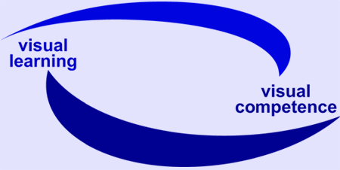
EU Project visuaLearning

Reference-No: 225773-CP-1-2005-1-DE-GRUNDTVIG-G1

Dissemination activities

Project Partner: DIE, Germany (Project Coordinator) Period: 01.10.2007 – 15.12.2007

Date | Activity / Product  (e.g. event, media, publication) | Target group  (participants, user –  please specity quantity if possible) | Remarks
8./9.10.2007 | DIE-Forum „Exlusion – Inklusion, Potenziale der Weiterbildung für gesellschaftliche Teilhabe“  Bonn | Researchers, practitioners, policy makers  100 participants
15./16.10.2007 | EU Project TRAIN Partner meeting  Waterford | Researchers  10 participants
24. – 26.10.2007 | Alphabetisierung und Grundbildung in Deutschland: Innovative Forschung – Innovative Praxis“  Hamburg | Researchers, practitioners, learnert  250 participants
30.11.2007 | 50 anniversary of DIE and award concerning innovative approaches in adult education | Researchers, practitioners, policy makers  200 participants
November 2007 | Newsletter NO. 4 | Researchers, practitioners | www.die-bonn.de/visual
Ongoing process | Website | Trainers, tutors, researchers | www.die-bonn.de/visual
Ongoing process | National and international Networking | Trainers, tutors, researchers,

