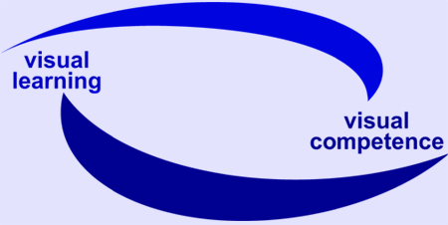
EU Project visuaLearning

Reference-No: 225773-CP-1-2005-1-DE-GRUNDTVIG-G1

Dissemination activities

Project Partner: IteE-PIB, Poland Period: 01.10.2007 – 15.12.2007

Date | Activity / Product  (e.g. event, media, publication) | Target group  (participants, user –  please specify quantity if possible) | Remarks
7-8.11.2007 | Study visit within TP ENTERPRISE for Europe, EQUAL | Authors of e-learning programmes; representatives from institutions which implement e-learning and multimedia programmes in teaching and learning; beneficiaries  15 participants | Portugal (Porto)
7-8.11.2007 | Study visit within TP TENKO, EQUAL | Representatives from national DPs, beneficiaries  15 participants | Spain (Madrit)
14.11.2007 | Session of National Thematic Networks (NTN) | Members of NTN, representatives of local authorities, experts,  85 participants | ITeE – PIB, Radom
15.11.2007 | Conference: Lifelong education of employees, IW EQUAL | Members of NTN, representatives of local authorities– The President of Radom city, experts, beneficiaries  90 participants | ITeE – PIB, Radom
22.11. 2007 | International conference: European Bank for the Development of Modular Curricula and Educational Technologies: With ModENet we cross borders | Representatives (among others): Ministry of National Education, Ministry of Economy, Ministry of Labour and Social Policy, National Centre for Supporting Vocational and Continuing Education; International institutions – partners of EMCET2 project, CEDEFOP, EFTA, EFT, Polish network ReferNet, Local Departments of Education and labour Agencies, representatives from press, media, journals.  120 participants | Academy of Special Pedagogy in Warsaw
4.12.2007 | Conference: Problems of Labour market and tendencies in education of rural areas inhabitants – projects carried out in the 2004 – 2006 term of funding | Representatives of local authorities, institutions which carried out EU projects, beneficiaries  20 participants | Zwoleń
13-14.12. 2007. | Seminar: Perspectives for the development of EQUAL Network of cooperation, Entrepreneurship in the web… | National DPs, representatives of national authorities, beneficiaries  80 participants | Jedlnia Letnisko – Radom, ITeE - PIB
October 2007 | Publication: Małgorzata Kacprzak, Dorota Koprowska, VisuaLearning – visual methods in adult education, in: Bednarczyk H., Łopacińska L., Baixeros L. Innovative technologies in digital learning for adult people from rural areas, ITeE; Radom, | 200 copies of the book
December 2007 | Newsletter No. 5 | Teachers, trainers, researchers, specialists in adult education and education in general
Ongoing process | Website of ITeE-PIB with the link to the project
Ongoing process | Local network

